Names:________________________________________________

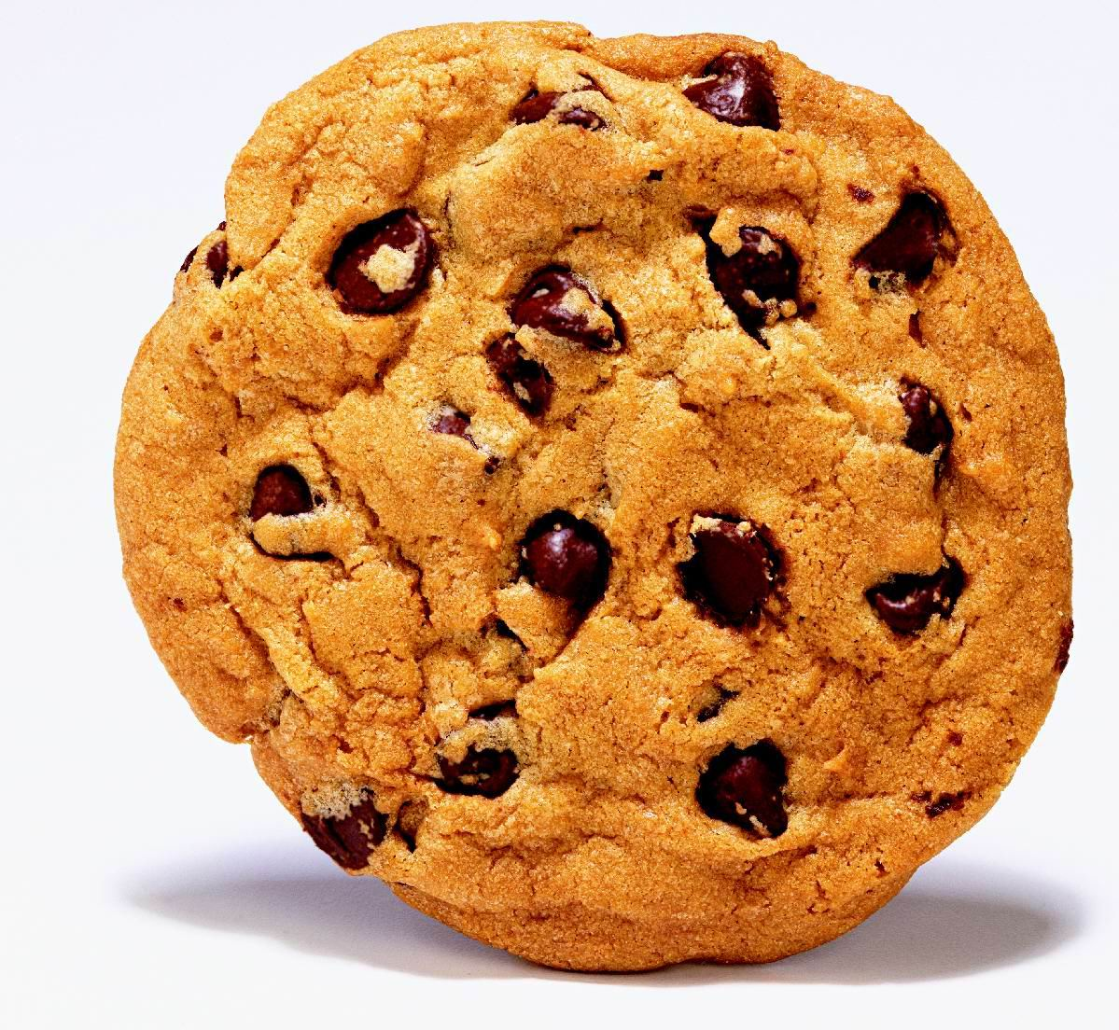  Number of Cookies: | Number of Friends: | How many cookies does each friend get?
6 | 3 | 2
6
6
6
6
6
6
6
6
6

